PICS. 1 – 16 OBTAINED FROM VESSEL.
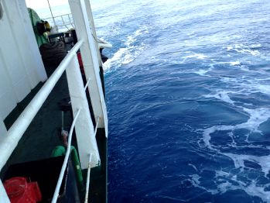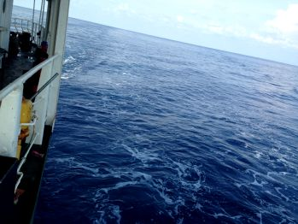
PICS. 1 – 2 SHOW SEA CONDITIONS AFTER PIRATES LEFT THE VESSEL.

PICS. 3 – 5 SHOW FOOT MARKS ON STARBOARD SIDE DECK.
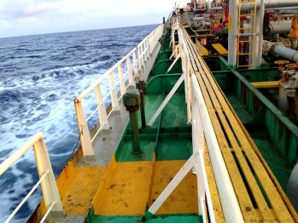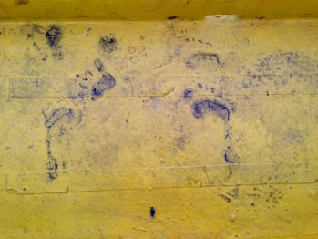
3. 4.

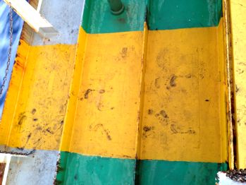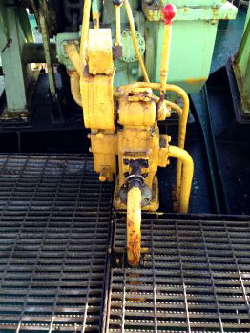
5. 6. HYDRAULIC PIPE FOR WINCH / WINDLASS.

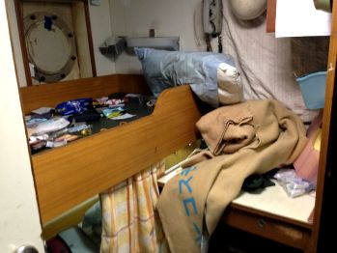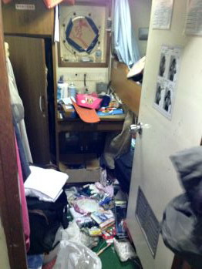
PICS. 7 – 8 SHOW MASTER’S CABIN WAS RANSACKED

PICS. 9 – 15 SHOW HYDRAULIC / AIR PIPES OF MAIN ENGINE.
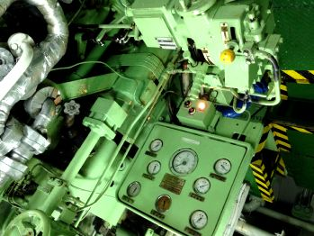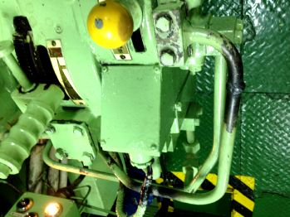
9. 10.

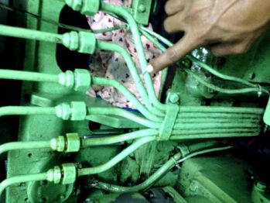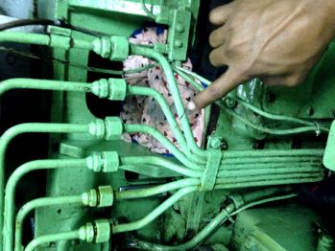
PICS. 11 – 12 SHOW PIPES CUT BY PIRATES.

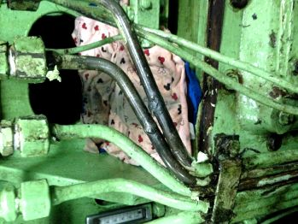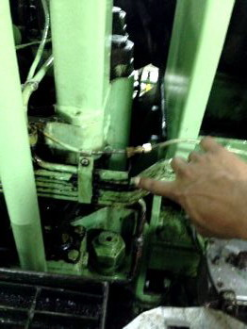
PICS. 13 – 14 SHOW PIPES TEMPORARILY REPAIRED BY SHIP’S CREW.

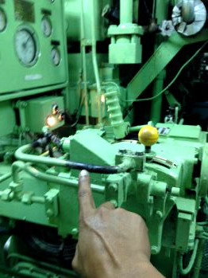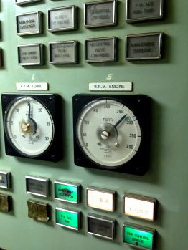
15. 16.

PICS. 17 – 60 SHOW OUR ATTENDANCE ON BOARD.
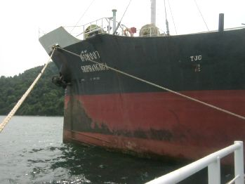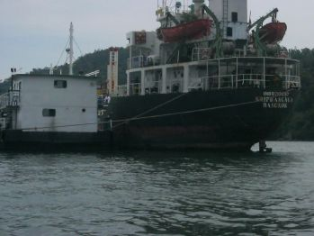
PICS. 17 – 18 SHOW GENERAL VIEW OF M.T. SRI PHANG NGA AT KOH KONG.

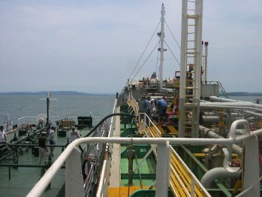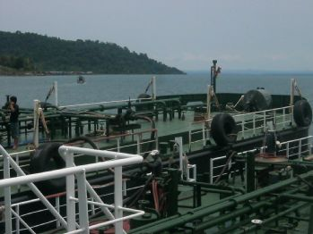
PICS. 19 – 20 SHOW CARGO DISCHARGING IN PROGRESS.

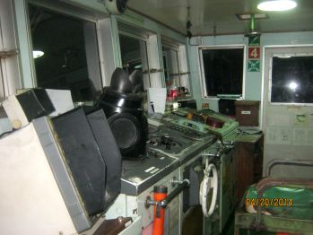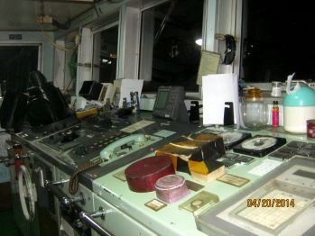
PICS. 21 – 22 SHOW GENERAL VIEW OF BRIDGE / WHEELHOUSE.

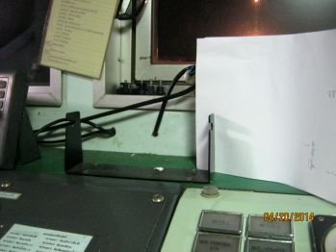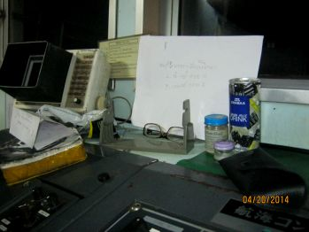
PICS. 23 – 24 SHOW GPS / VHF WERE MISSING – REPORTEDLY TAKEN BY PIRATES.

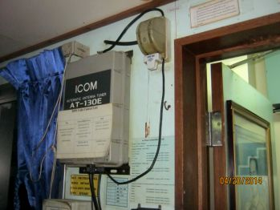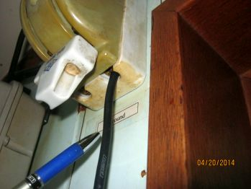
PICS. 25 – 26 SHOW TEMPORARILY REPAIRED AERIAL WIRE.

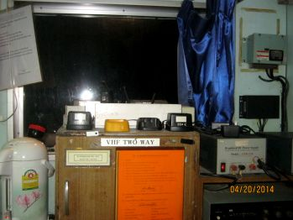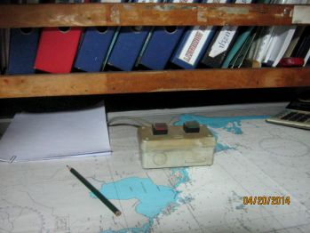
27. PORTABLE VHF WALKIE TALKIES 28. SSAS ALARM BUTTON.
– REPORTEDLY TAKEN BY PIRATES. BEING DEMONSTRATED BY MASTER.

PICS. 29 – 36 SHOW TEMPORARILY REPAIRED PIPES IN ENGINE ROOM.
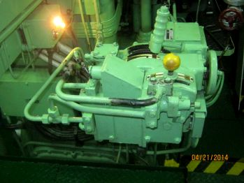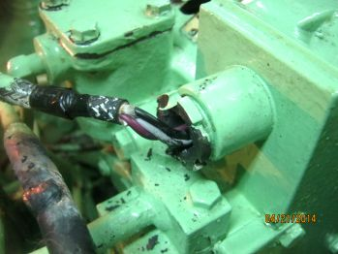
29. 30.

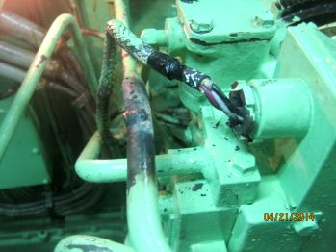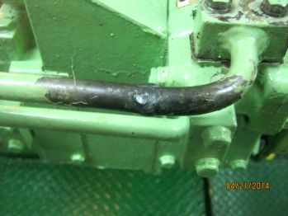
31. 32.

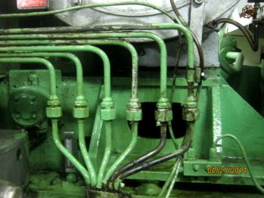 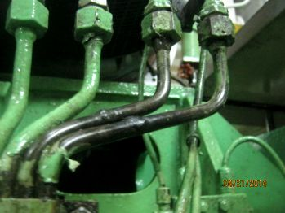\
33. 34.

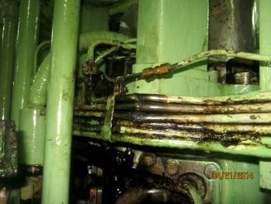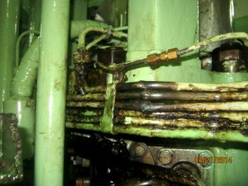
35. 36.

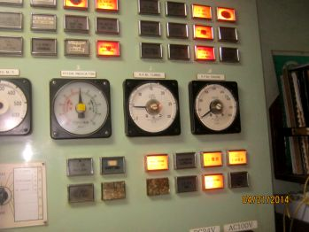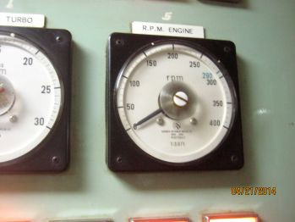
PICS. 37 – 38 SHOW PANEL FOR MAIN ENGINE.

PICS.39-44 SHOW FUNNEL WAS PAINTED OVER BY PIRATES / LETTER ‘N’ COVERED.
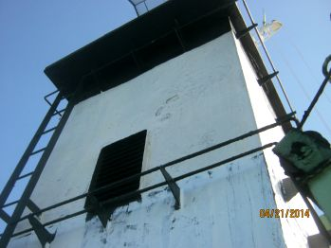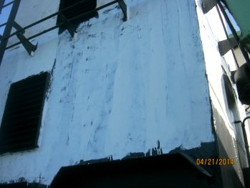
39. 40.

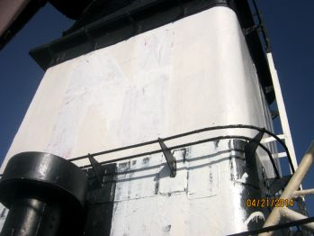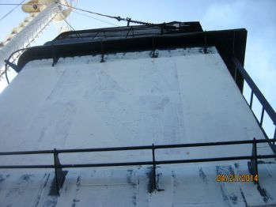
41. 42.

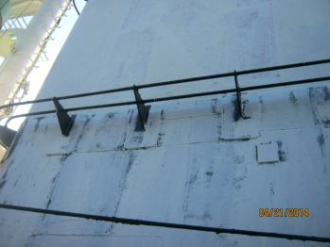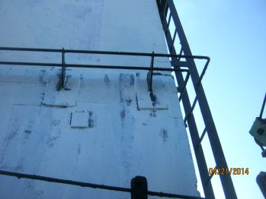
43. 44.

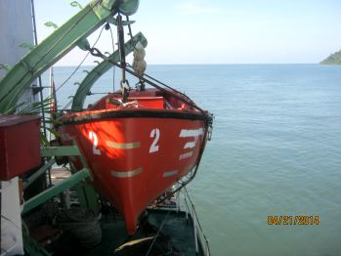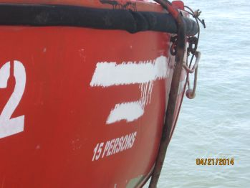
PICS. 45 – 46 SHOW SHIP’S NAME PAINTED OVER ON PORT SIDE LIFE BOAT.

PICS. 47 – 50 SHOW TEMPORARILY REPAIRED HYDRAULIC PIPES ON WINDLASS.
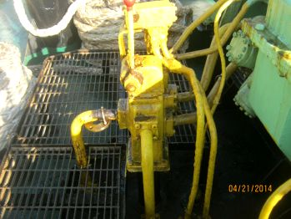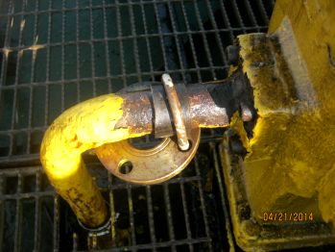
47. 48.

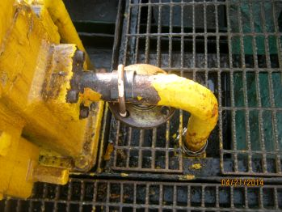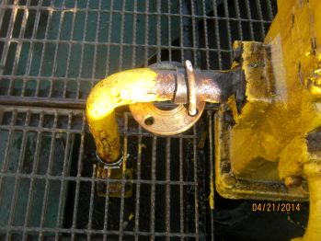
49. 50.

PICS. 51 – 53 SHOW MASTER’S CABIN HAD BEEN RANSACKED.
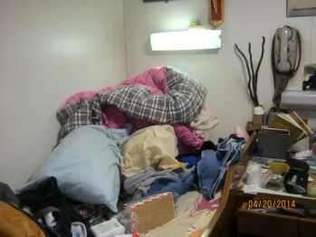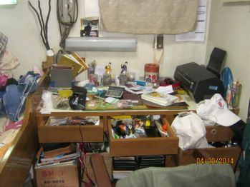
51. 52.

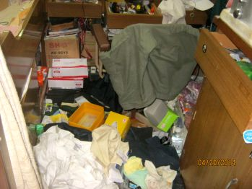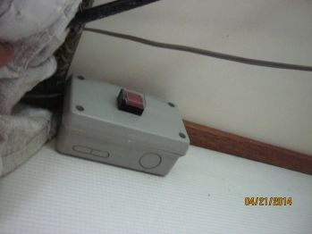
53. 54. SSAS SWITCH IN MASTER’S CABIN.

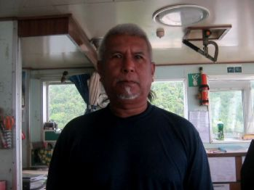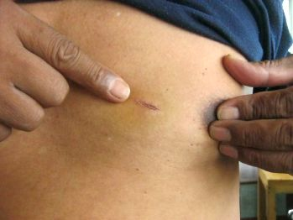
PICS. 55 – 56 SHOW MASTER / WOUND ON HIS CHEST –
WHILE PIRATES THREATENED HIM WITH KNIFE.

PICS. 57 – 60 SHOW CARGO SAMPLES COLLECTED / SEALED / KEPT WITH MASTER.
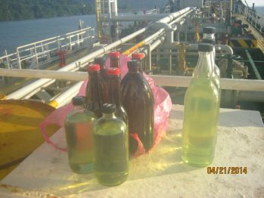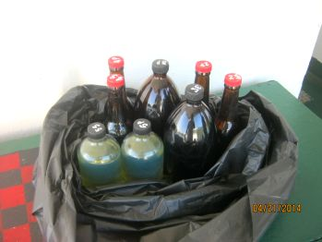
57. 58.

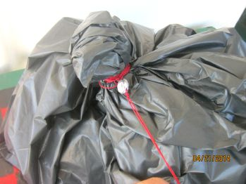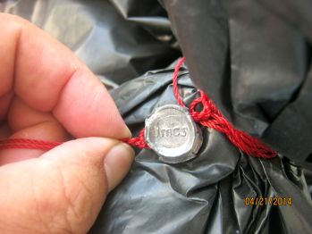
59. 60.

